**Name: Shoaib Ahmed**

**Intern ID: TN/IN02/PY/027**

**Task no: week 6 task**

**Internship domain: python language**

**Date: 28 August 2025**

**Task week 6:**

You have to make a Simple web page using html css and flask then convert your app to Docker image and run this image

Answer:

First I download the dockar app and after that I make the folder with the name of dockor app and after that I made different files:

flask_docker_app/

├─ app.py

├─ requirements.txt

├─ Docker file

├─ templates/

│ └─ index.html

└─ static/

└─ style.css

These are the files structure of my work. after that I take the files and give command to vs code

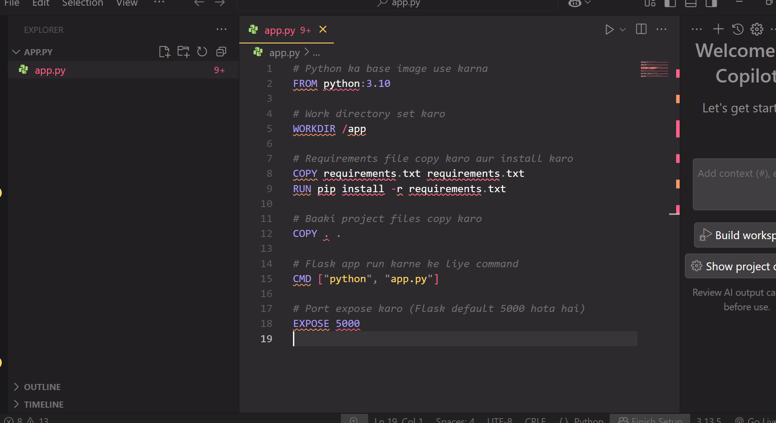

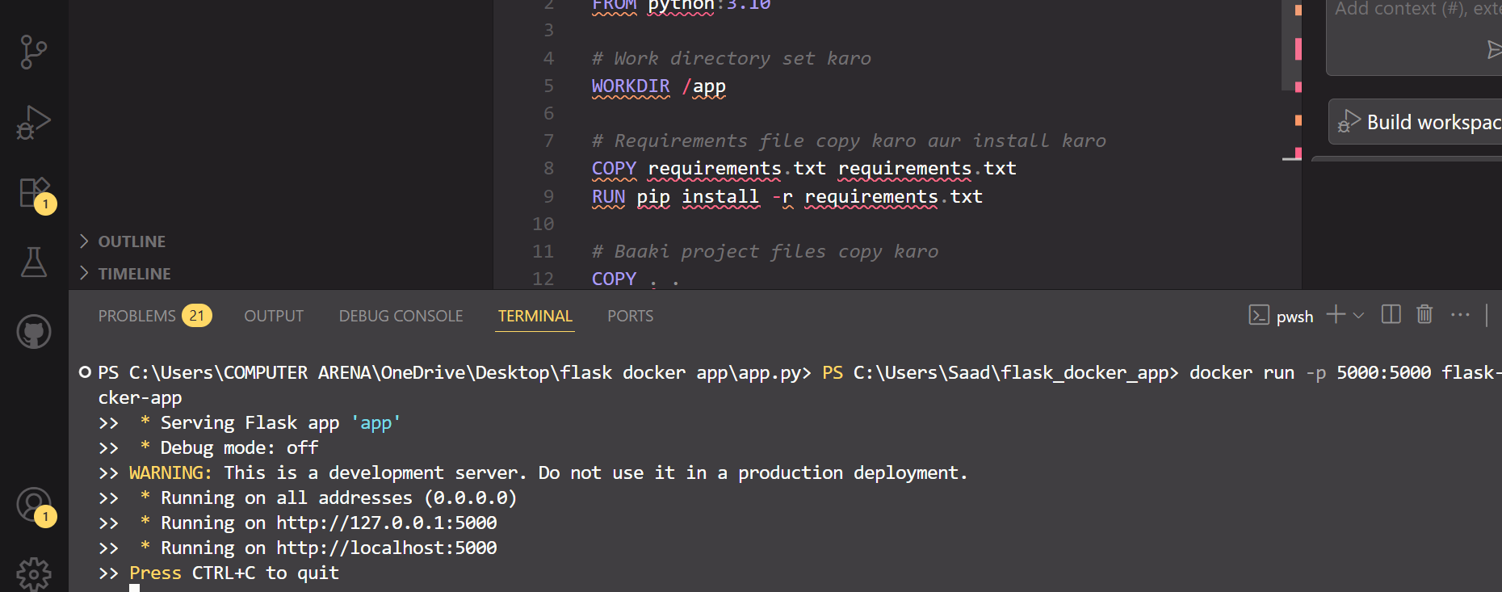

After doing this I give the commands to power shells that where exactly the path of the files and the folders is:

